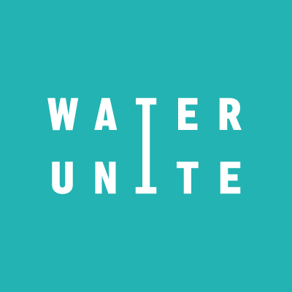
Water Unite

Water Unite is a UK based, non-profit organisation that works in partnership with the private sector to raise and invest funds for clean water sanitation and plastics recycling. Funds are raised via voluntary donations of around one cent per litre from retailers of bottled water.

Started in 2018, Water Unite is supported by Co-op, Elior UK, The Rockefeller Foundation, Stone, Vitol and One Foundations. Water Unite aims to raise US$100-$200 million in the next 2 years.

In 2018, Co-op UK became the first company to join the Water Unite initiative, donating a penny per litre from all branded water it sells across its 2,600 stores in the UK to contribute to the initiative. In 2019, Elior UK, the British arm of the €6bn French company, joined Water Unite in a foodservice industry first in October.

Explainer Video: www.youtube.com/watch?v=9eGMv2_6TIU

HIGH RES LOGOS CAN BE FOUND HERE: https://www.waterunite.org/media-pack/

NOTES TO EDITORS:

Media contact: Connie Goring-Morris, connie@waterunite.org / +44 7872 506372

For more information please visit waterunite.org

